Screen 2: Public Website – Temple Registration (Multi-Step Flow)

Purpose
This flow enables:
- New ISKCON temples to self-register
- Capture President & Vice-President details
- Automatically create login credentials for President & Vice-President

Flow Structure (Step-Based UX)
Step 1: Temple Basic Details
Step 2: President Details
Step 3: Vice-President Details
Step 4: Review & Submit
Step 5: Success Screen

Temple Registration Form UI

Step1 Image

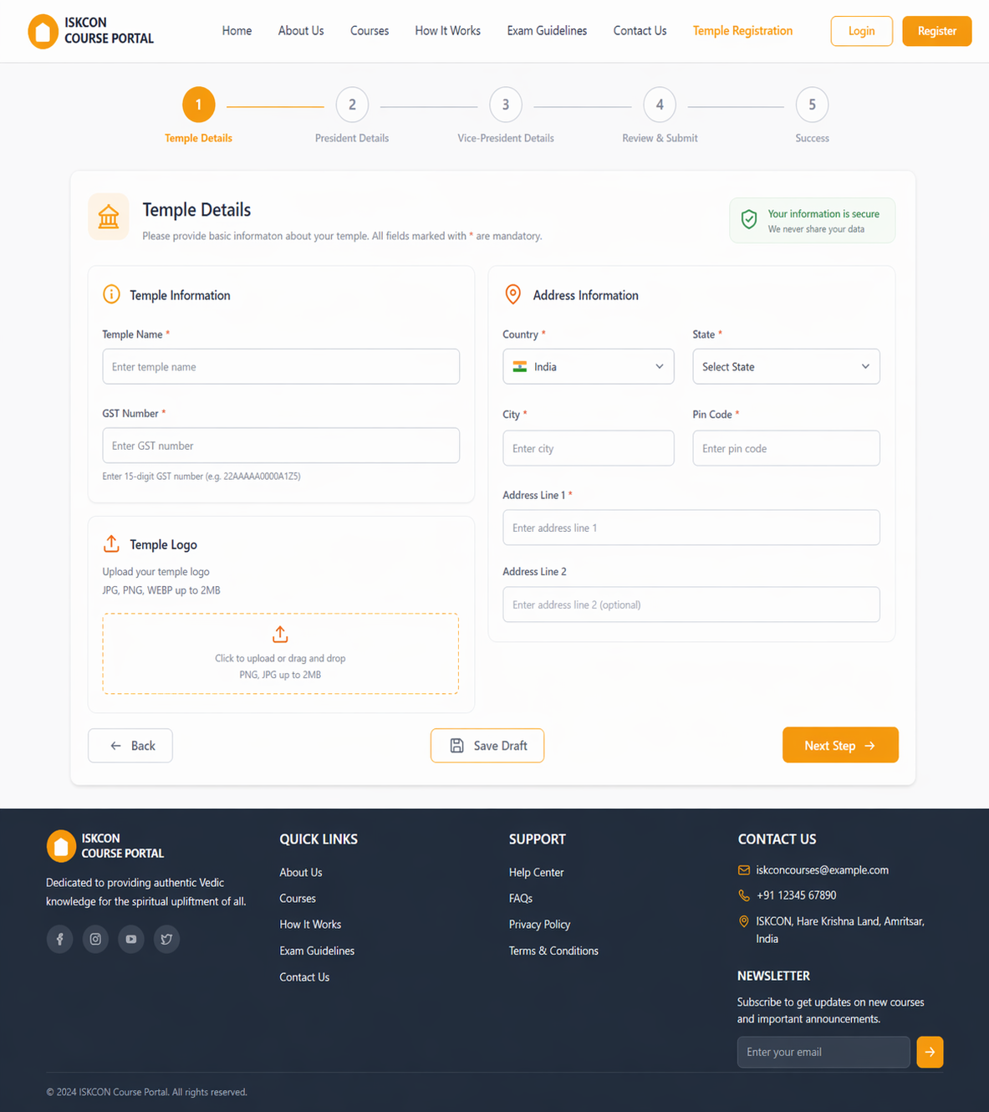

Step2 Image
Make sure, if one drop down is opened then other opened drop down will get closed
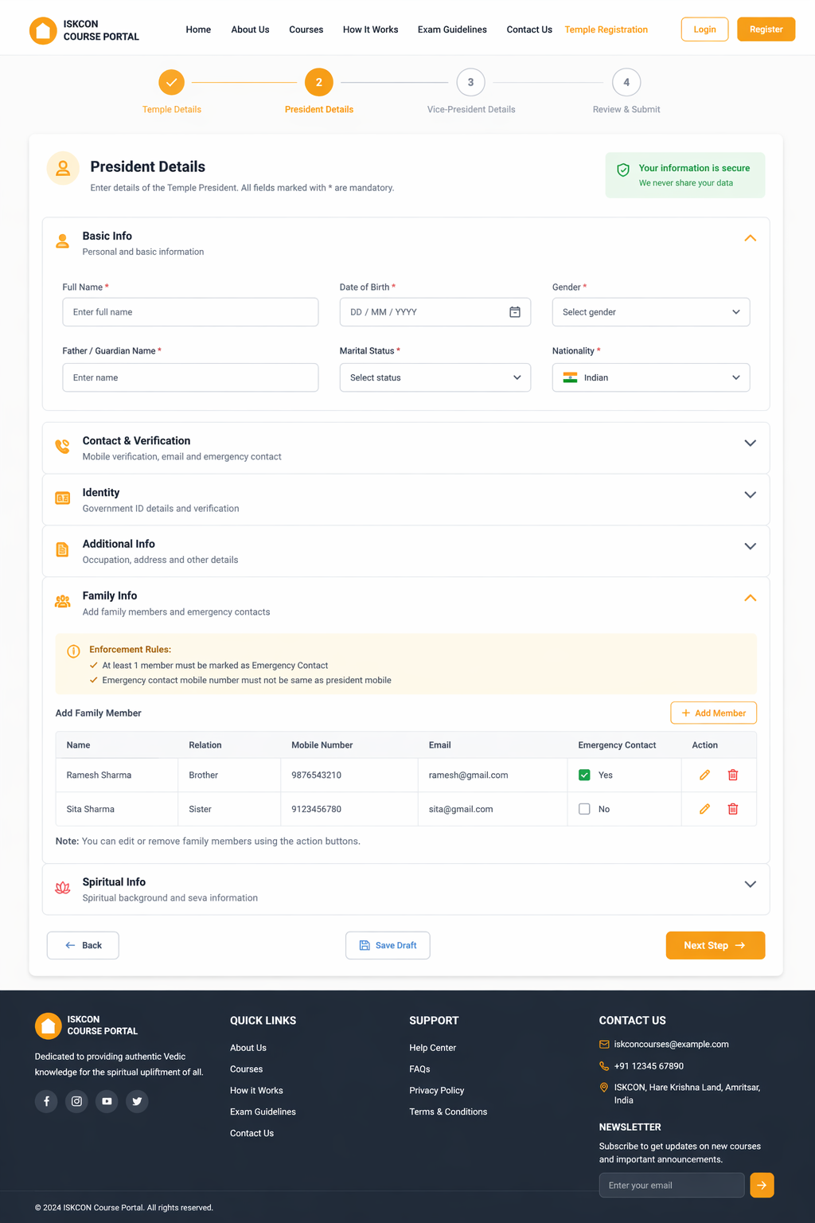

Step3 Image
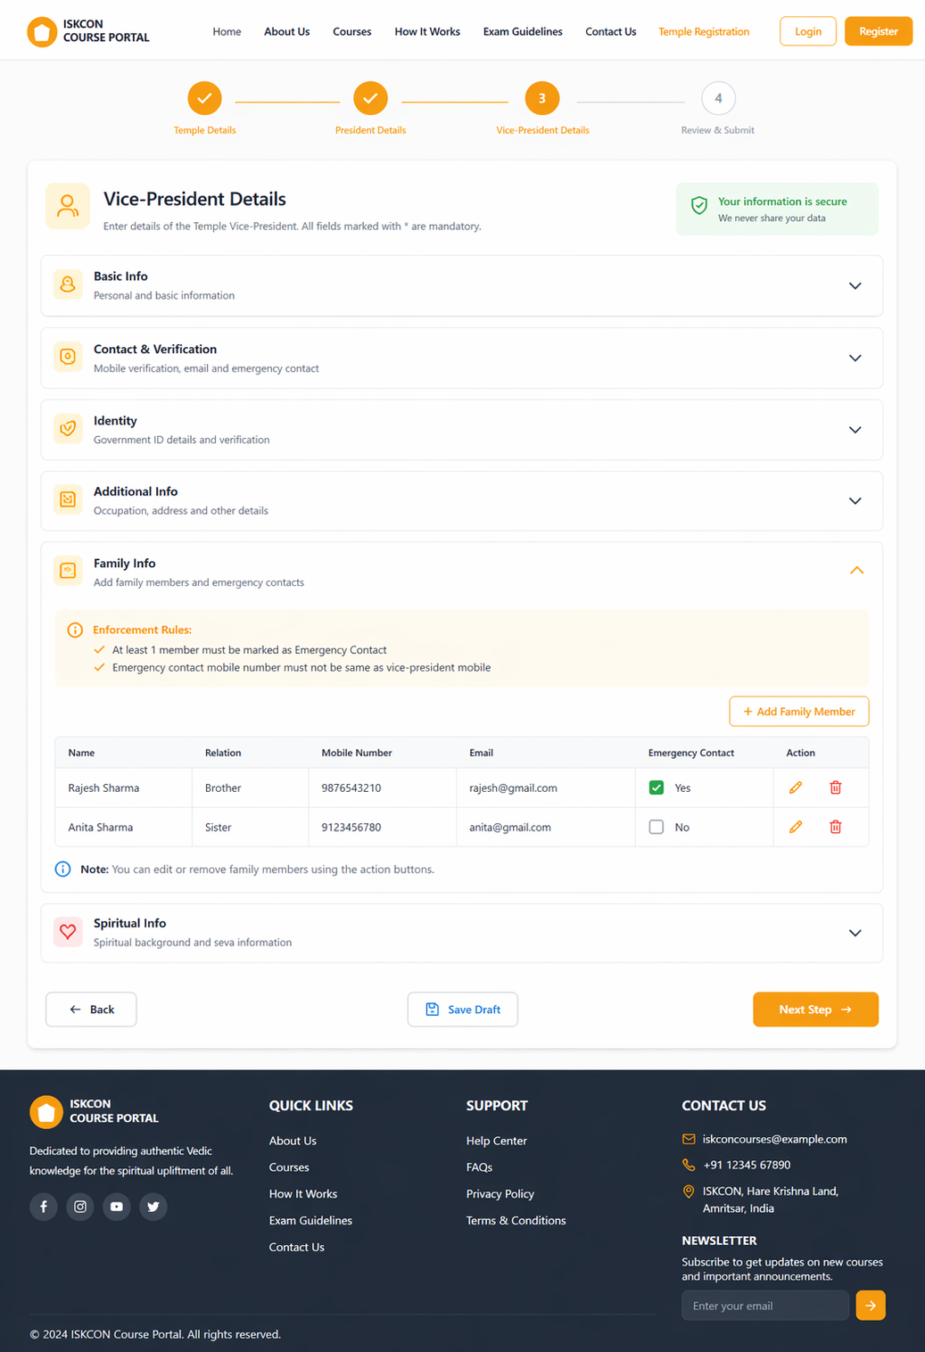

Step4 Image
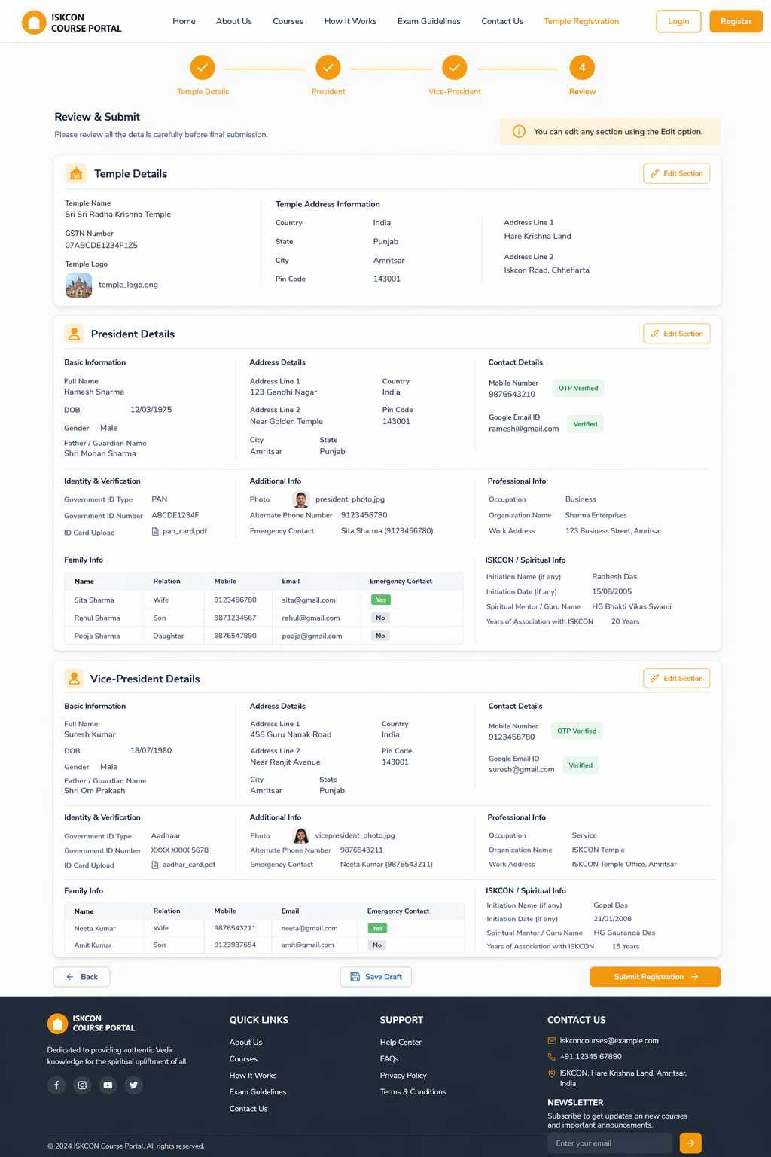

Step5 Image


Temple Registration Form Content

STEP 1: Temple Basic Details
Fields:
- Temple Name *
- GSTN Number *
- Temple Logo Upload
- Country *
- State * (GET /api/location/states-by-country?countryCode=IN)
- City *
- Pin Code *
- Address Line 1 *
- Address Line 2 *
Buttons:
- Back - disabled
- Next Button (Save Step1 details)
  - Save Step1 - URL: /api/temple-registration/step1

Validations:
Field Name | Mandatory (Y/N) | Client-Side Validation | Server-Side Validation | Error Message
Temple Name | Y | 3-150 chars, text only | Sanitize + length check | Invalid temple name
GSTN Number | Y | 15 char GSTIN format | Regex + uniqueness check | Invalid GSTN
Temple Logo Upload | N | jpg/png/gif/pdf, max 5MB | MIME type + size check | Invalid file format
Country | Y | Dropdown selection | Enum validation | Invalid country
State | Y | Dropdown selection | Enum validation | Invalid state
City | Y | Alphabets only | Sanitize | Invalid city
Pin Code | Y | 6 digit numeric | Regex check | Invalid pincode
Address Line 1 | Y | Text, max 200 chars | Sanitize | Invalid address
Address Line 2 | Y | Text, max 200 chars | Sanitize | Invalid address

STEP 2: Temple President Details
Fields: Mandatory Fields
Basic Information ▼
- Full Name *
- DOB
- Gender
- Father’s Name
Address Details ▼
- Address Line 1
- Address Line 2
- City
- State
- Country
- Pin Code

Contact Details▼
- Mobile Number * (OTP Verified)
- Google Email ID * (validated)

Identity & Verification▼
- Government ID Type (Aadhar / PAN / Passport) drop down
- Government ID Number*
- Govt. ID-Card Upload*

Additional Info (Non-Mandatory Fields) ▼
Personal Info
- Photo
- Alternate Phone Number
- Emergency Contact
Professional Info
- Occupation
- Organization Name
- Work Address
Family Info▼
- fullName
- relation
- mobile
- email
- isEmergencyContact

ISKCON/Spiritual Info▼
- Initiation Name (if any)
- Initiation Date (if any)
- Spiritual Mentor / Guru Name
- Years of Association with ISKCON

Buttons:
- Next Button – Save Step2 (Endpoint: /api/temple-registration/step2)
- Back Button - GET: /api/temple-registration/step1/{templeId}

Validations:
Field Name | Mandatory (Y/N) | Client-Side Validation | Server-Side Validation | Error Message
Full Name | Y | Alphabets + spaces, 3-100 chars | Sanitize, length check | Invalid name
Photo Upload | Y | jpg/png/gif/pdf, max 5MB | MIME type check, size limit | Invalid file format
DOB | N | Valid date, age >=18 | Age validation | Age must be >=18
Gender | N | Dropdown | Enum validation | Invalid gender
Father’s Name | Y
Address Line 1 | N | Text | Sanitize | Invalid input
City | N | Alphabets only | Sanitize | Invalid city
State | N | Dropdown, autopopulated basis on country selection | Enum validation | Invalid state
Country | N | Dropdown | Enum validation | Invalid country
Pin Code | N | 6 digit numeric | Regex check | Invalid pincode
Mobile Number | Y | 10 digit + OTP verify | Unique + OTP validation | Invalid/duplicate mobile
Google Email Id | Y | Must end @gmail.com | Unique + domain check | Invalid email
Govt ID Type | Y | Dropdown | Enum validation | Invalid ID type
PAN Number | Y | PAN regex | Unique + regex | Invalid PAN
Aadhaar | Y | 12 digit numeric | Unique + regex | Invalid Aadhaar
Passport | Y | 6-9 chars alphanumeric | Regex | Invalid passport
Govt ID Upload | Y | Allowed formats | MIME/type check | Invalid file
Alternate Phone | N | 10 digit numeric | Format check | Invalid number
Emergency Contact
Occupation | N | Text | Sanitize | Invalid input
Organization Name | N | Text | Sanitize | Invalid input
Work Address | N | Text | Sanitize | Invalid input
Family Info
Name
Relation
Mobile
Email
Emergency Contact
Initiation Name | N | Text | Sanitize | Invalid input
Initiation Date | N | Date | Date validation | Invalid date
Guru Name | N | Text | Sanitize | Invalid input
Years of Association | N | 0-100 numeric | Range check | Invalid value
Cross Validation (President vs VP) | Y | Compare mobile/email/PAN | Strict uniqueness check | Cannot be same person

Family Details
fullName | N | 0-100 numeric | Range check | Invalid name
Relation | N | Compare mobile/email/PAN | Relation must be from ENUM:  SPOUSE, FATHER, MOTHER, SON, DAUGHTER, BROTHER, SISTER, OTHER | Invalid relation
mobile | N | 10 digit |  | Invalid mobile
email | N | Valid format |  | Invalid email
isEmergencyContact | N | At least 1 required | Emergency contact must NOT be same as user mobile | Select emergency contact

STEP 3: Vice-President Details
(Same structure as Step 2)
Fields: Mandatory Fields
Basic Information ▼
- Full Name *
- DOB
- Gender
- Father’s Name
Address Details ▼
- Address Line 1
- Address Line 2
- City
- State
- Country
- Pin Code

Contact Details▼
- Mobile Number * (OTP Verified)
- Google Email ID * (validated)

Identity & Verification▼
- Government ID Type (Aadhar / PAN / Passport) drop down
- Government ID Number*
- Govt. ID-Card Upload*

Additional Info (Non-Mandatory Fields) ▼
Personal Info
- Photo
- Alternate Phone Number
- Emergency Contact
Professional Info
- Occupation
- Organization Name
- Work Address
Family Info▼
- fullName
- relation
- mobile
- email
- isEmergencyContact

ISKCON/Spiritual Info▼
- Initiation Name (if any)
- Initiation Date (if any)
- Spiritual Mentor / Guru Name
- Years of Association with ISKCON
Button:
Next - Endpoint: /api/temple-registration/step3 (Save Step3 details)
Back - GET: /api/temple-registration/step2/{templeId}

Validations:
Field Name | Mandatory (Y/N) | Client-Side Validation | Server-Side Validation | Error Message
Full Name | Y | Alphabets + spaces, 3-100 chars | Sanitize, length check | Invalid name
Photo Upload | Y | jpg/png/gif/pdf, max 5MB | MIME type check, size limit | Invalid file format
DOB | N | Valid date, age >=18 | Age validation | Age must be >=18
Gender | N | Dropdown | Enum validation | Invalid gender
Father’s Name | Y
Address Line 1 | N | Text | Sanitize | Invalid input
City | N | Alphabets only | Sanitize | Invalid city
State | N | Dropdown, autopopulated basis on country selection | Enum validation | Invalid state
Country | N | Dropdown | Enum validation | Invalid country
Pin Code | N | 6 digit numeric | Regex check | Invalid pincode
Mobile Number | Y | 10 digit + OTP verify | Unique + OTP validation | Invalid/duplicate mobile
Google Email Id | Y | Must end @gmail.com | Unique + domain check | Invalid email
Govt ID Type | Y | Dropdown | Enum validation | Invalid ID type
PAN Number | Y | PAN regex | Unique + regex | Invalid PAN
Aadhaar | Y | 12 digit numeric | Unique + regex | Invalid Aadhaar
Passport | Y | 6-9 chars alphanumeric | Regex | Invalid passport
Govt ID Upload | Y | Allowed formats | MIME/type check | Invalid file
Alternate Phone | N | 10 digit numeric | Format check | Invalid number
Emergency Contact
Occupation | N | Text | Sanitize | Invalid input
Organization Name | N | Text | Sanitize | Invalid input
Work Address | N | Text | Sanitize | Invalid input
Family Info
Name
Relation
Mobile
Email
Emergency Contact
Initiation Name | N | Text | Sanitize | Invalid input
Initiation Date | N | Date | Date validation | Invalid date
Guru Name | N | Text | Sanitize | Invalid input
Years of Association | N | 0-100 numeric | Range check | Invalid value
Cross Validation (President vs VP) | Y | Compare mobile/email/PAN | Strict uniqueness check | Cannot be same person

Family Details
fullName | N | 0-100 numeric | Range check | Invalid name
Relation | N | Compare mobile/email/PAN | Relation must be from ENUM:  SPOUSE, FATHER, MOTHER, SON, DAUGHTER, BROTHER, SISTER, OTHER | Invalid relation
mobile | N | 10 digit |  | Invalid mobile
email | N | Valid format |  | Invalid email
isEmergencyContact | N | At least 1 required | Emergency contact must NOT be same as user mobile | Select emergency contact

STEP 4: Review & Submit
Layout:
- Read-only summary of all entered data
- When click on Edit link, respective page (Step1/2/3) will get redirected

Sections:
- Temple Details ▼ (Edit link)
  - Temple Name *
  - GSTN Number *
  - Temple Logo Upload
Address Information (Edit link)
  - Country *
  - Country *
  - State *
  - City *
  - Pin Code *
  - Address Line 1 *
  - Address Line 2
- President Details ▼ (Edit link)
Basic Information
  - Full Name *
  - DOB
  - Gender
  - Father/ Guardian Name
Address Details
  - Address Line 1
  - Address Line 2
  - City
  - State
  - Country
  - Pin Code

Contact Details
  - Mobile Number * (OTP Verified)
  - Google Email ID * (validated)

Identity & Verification
  - Government ID Type (Aadhar / PAN / Passport)
  - Government ID Number*
  - Govt. ID-Card Upload*

Additional Info (Non-Mandatory Fields)
Personal Info
  - Photo
  - Alternate Phone Number
  - Emergency Contact
Professional Info
  - Occupation
  - Organization Name
  - Work Address

Family Info
  - fullName
  - relation
  - mobile
  - email
  - isEmergencyContact
ISKCON/Spiritual Info
  - Initiation Name (if any)
  - Initiation Date (if any)
  - Spiritual Mentor / Guru Name
  - Years of Association with ISKCON
- Vice-President Details ▼ (Edit link)
Basic Information
  - Full Name *
  - DOB
  - Gender
  - Father/ Guardian Name
Address Details
  - Address Line 1
  - Address Line 2
  - City
  - State
  - Country
  - Pin Code

Contact Details
  - Mobile Number * (OTP Verified)
  - Google Email ID * (validated)

Identity & Verification
  - Government ID Type (Aadhar / PAN / Passport)
  - Government ID Number*
  - Govt. ID-Card Upload*

Additional Info (Non-Mandatory Fields)
Personal Info
  - Profile Photo
  - Alternate Phone Number
  - Emergency Contact
Professional Info
  - Occupation
  - Organization Name
  - Work Address
Family Info
  - fullName
  - relation
  - mobile
  - email
  - isEmergencyContact
ISKCON/Spiritual Info
  - Initiation Name (if any)
  - Initiation Date (if any)
  - Spiritual Mentor / Guru Name
  - Years of Association with ISKCON

Actions:
- Edit (per section)
- Submit Registration (Endpoint: /api/temple-registration/submit)
- Back - GET: /api/temple-registration/step3/{templeId}

STEP 5: Success Screen
Message:
“Temple Registered Successfully!”

Information Displayed:
- Confirmation message
- Login created for:
  - President
  - Vice-President

Actions:
- Go to Login
- Back to Home

Primary Actions
- Next Step
- Submit Registration

Secondary Actions
- Back
- Edit Details

Temple Registration API Details :

API 1– Country, State interdependent
1. API 1 – States Auto-Populate (Country → States)
Sample Request

GET /api/location/states-by-country?countryCode=IN
Sample Response

{
"success": true,
"data": {
"country": {
"_id": "65f1c2a1",
"name": "India",
"code": "IN",
"phoneCode": "+91"
},
"states": [
{ "_id": "s1", "name": "Karnataka", "code": "KA" },
{ "_id": "s2", "name": "Maharashtra", "code": "MH" }
]
}
}

API 2 – Bulk Upsert (Enterprise Level)
Endpoint

POST /api/location/bulk-upsert
Sample Request

{
"countries": [
{
"name": "India",
"code": "IN",
"phoneCode": "+91",
"states": [
{ "name": "Karnataka", "code": "KA" },
{ "name": "Tamil Nadu", "code": "TN" }
]
},
{
"name": "USA",
"code": "US",
"phoneCode": "+1",
"states": [
{ "name": "California", "code": "CA" },
{ "name": "Texas", "code": "TX" }
]
}
]
}

3. API 3 – Soft Delete
Endpoint

API 3 – Soft Delete
Sample Request

{
"countryId": "65f1c2a1"
}
OR

{
"countryName": "India"
}

Sample DB JSON Collection
Countries
[
{
"_id": "c1",
"name": "India",
"code": "IN",
"phoneCode": "+91",
"isActive": true,
"createdAt": "2026-01-01T00:00:00Z"
}
]

States
[
{
"_id": "s1",
"countryId": "c1",
"name": "Karnataka",
"code": "KA",
"isActive": true,
"createdAt": "2026-01-01T00:00:00Z"
}
]

API 2– Temple Basic Details (Next Step 1 Save/Update)

1. Endpoint
- Method: POST
- URL: /api/temple-registration/step1

2. Description
This API handles Step 1: Temple Basic Details from the multi-step registration flow.
- Saves or updates temple data when user clicks “Next Step”
- Creates a draft temple record (status = DRAFT)
- Supports idempotent upsert (new or existing draft using templeId)
- Stores logo as file reference (file_metadata)
- Prepares data for Step 2 (President)
This aligns with the multi-step UX defined in the FSD

3. Request Payload (JSON)
{
"templeId": "optional-existing-id",
"name": "ISKCON Bangalore",
"gstn": "29ABCDE1234F1Z5",
"address": {
"line1": "Rajajinagar",
"line2": "Near Orion Mall",
"city": "Bangalore",
"state": "Karnataka",
"country": "India",
"pinCode": "560010"
},
"logoFileId": "file_object_id_optional"
}

4. Response Payload (JSON)
{
"success": true,
"message": "Temple details saved successfully",
"data": {
"templeId": "65fabc1234",
"status": "DRAFT",
"nextStep": "PRESIDENT_DETAILS"
}
}

5. Client-Side Validation:
Field Validations
- Temple Name
  - Required
  - 3–150 chars
  - Alphabets + spaces only
- GSTN
  - Required
  - Regex: ^[0-9]{2}[A-Z]{5}[0-9]{4}[A-Z]{1}[1-9A-Z]{1}Z[0-9A-Z]{1}$
- Address:
  - Line1 → Required, max 200 chars
  - Line2 → Required, max 200 chars
  - City → Alphabets only
  - State → Dropdown mandatory
  - Country → Dropdown mandatory
  - PinCode → 6 digit numeric
- Logo Upload:
  - Optional
  - Allowed: jpg/png/pdf/gif
  - Max size: 5MB

Button Behavior
- Next Button
  - Disabled until all mandatory fields valid
  - On click → call API
  - Show loader
- Back Button
  - Not applicable (first step)

Edge Cases
- GSTN invalid format
- Empty required fields
- Unsupported file type
- Network failure → retry option

6. Server-Side Validation:
Field Validation
- Sanitize all text inputs (XSS prevention)
- Trim & normalize strings
Business Rules
- GSTN must be unique
- Temple name indexed for search
- Address must be complete
DB Constraints
- Unique index on gstn
- Soft delete aware (isDeleted = false)
File Validation
- Validate file exists in file_metadata
- Ensure ownership/session linkage

8. Mongo DB JSON Collection
temples collection

{
"_id": "65fabc1234",
"name": "ISKCON Bangalore",
"gstn": "29ABCDE1234F1Z5",
"address": {
"line1": "Rajajinagar",
"line2": "Near Orion Mall",
"city": "Bangalore",
"state": "Karnataka",
"country": "India",
"pinCode": "560010"
},
"logoFileId": "file123",
"status": "DRAFT",
"isDeleted": false,
"createdAt": "2026-04-18T10:00:00Z",
"updatedAt": "2026-04-18T10:05:00Z"
}
file_metadata collection (if logo uploaded)

{
"_id": "file123",
"fileName": "temple-logo.png",
"fileType": "image/png",
"fileSize": 245678,
"url": "https://cdn.domain.com/uploads/temple-logo.png",
"uploadedBy": null,
"createdAt": "2026-04-18T09:59:00Z"
}
audit_logs collection

{
"_id": "audit1",
"entity": "temples",
"entityId": "65fabc1234",
"action": "CREATE_DRAFT",
"performedBy": null,
"timestamp": "2026-04-18T10:00:01Z"
}

9. Notes (Optional)
Use upsert strategy:

findOneAndUpdate({ _id: templeId }, data, { upsert: true })
- Add indexes:
  - gstn (unique)
  - name (text index)
  - status
- Consider draft expiry cleanup job (cron)
- Store currentStep = 1 for flow tracking (optional enhancement)

API 3– President Details (Next Step 2 Save/Update)

1. Endpoint
Method: POST
URL: /api/temple-registration/step2

2. Description
This API handles Step 2: President Details in the temple registration flow.
- Saves or updates President information
- Ensures OTP verification for mobile
- Validates Gmail-only email
- Stores uploaded files via file_metadata references
- Links President data to the existing temple (Step 1)
- Keeps data in draft mode (user NOT created yet)
This follows the validation-heavy onboarding defined in FSD

3. Request Payload (JSON)
{
"templeId": "65fabc1234",

"fullName": "Ramesh Sharma",
"dob": "1985-05-10",
"gender": "MALE",

"address": {
"line1": "Rajajinagar",
"line2": "Near Orion Mall",
"city": "Bangalore",
"state": "Karnataka",
"country": "India",
"pinCode": "560010"
},

"mobile": "9876543210",
"otp": "456789",

"email": "ramesh@gmail.com",

"govtIdType": "PAN",
"govtIdNumber": "ABCDE1234F",

"photoFileId": "file_photo_123",
"govtIdFileId": "file_id_456",

"additionalInfo": {
"alternatePhone": "9123456780",
"occupation": "Business",
"organizationName": "ISKCON Org",
"yearsOfAssociation": 10
}
}

4. Response Payload (JSON)
{
"success": true,
"message": "President details saved successfully",
"data": {
"templeId": "65fabc1234",
"presidentDraftSaved": true,
"nextStep": "VICE_PRESIDENT_DETAILS"
}
}

5. Client-Side Validation:
Mandatory Fields
- Full Name → alphabets + spaces (3–100 chars)
- Photo Upload → required
- Mobile Number → 10 digit
- OTP → required after clicking verify
- Email → must end with @gmail.com
- Govt ID Type → dropdown
- Govt ID Number → based on type
- Govt ID Upload → required

Field Rules
- PAN → [A-Z]{5}[0-9]{4}[A-Z]{1}
- Aadhaar → 12 digit numeric
- Passport → 6–9 alphanumeric
- DOB → age >= 18
- City → alphabets only
- PinCode → 6 digit numeric

Button Behavior
- Verify OTP button
  - Calls OTP API (API 9)
  - Enables Next only after success
- Next Button
  - Disabled until:
    - OTP verified
    - All mandatory fields valid
- Back Button
  - Navigate to Step 1 (no API call here)

Edge Cases
- OTP expired
- Duplicate mobile/email
- Invalid PAN/Aadhaar format
- File not uploaded
- Same email typed with uppercase (normalize)

6. Server-Side Validation:
Field Validation
- Sanitize all fields (XSS, injection)
- Normalize:
  - email → lowercase
  - PAN → uppercase

Business Rules
- Mobile must be:
  - OTP verified (otp_verifications.isUsed = true)
- Email:
  - Must end with @gmail.com
- Govt ID:
  - Must be unique across system
- President must be unique per temple

Cross Validation
- Prevent duplicate:
  - mobile
  - email
  - govtIdNumber

OTP Validation
- Check:
  - OTP exists
  - Not expired
  - Not already used
- Mark OTP as used

File Validation
- Ensure:
  - photoFileId exists
  - govtIdFileId exists

8. Mongo DB JSON Collection
(Draft storage inside temples OR temp collection)
👉 Recommended: store in temples as embedded draft
{
"_id": "65fabc1234",
"name": "ISKCON Bangalore",
"status": "DRAFT",

"president": {
"fullName": "Ramesh Sharma",
"dob": "1985-05-10",
"gender": "MALE",

"address": {
"line1": "Rajajinagar",
"line2": "Near Orion Mall",
"city": "Bangalore",
"state": "Karnataka",
"country": "India",
"pinCode": "560010"
},

"mobile": "9876543210",
"email": "ramesh@gmail.com",

"govtIdType": "PAN",
"govtIdNumber": "ABCDE1234F",

"photoFileId": "file_photo_123",
"govtIdFileId": "file_id_456",

"isMobileVerified": true
},

"updatedAt": "2026-04-18T11:00:00Z"
}
otp_verifications collection

{
"_id": "otp123",
"mobile": "9876543210",
"otp": "456789",
"expiresAt": "2026-04-18T11:05:00Z",
"isUsed": true
}
file_metadata collection

{
"_id": "file_photo_123",
"fileName": "president-photo.jpg",
"fileType": "image/jpeg",
"fileSize": 345678,
"url": "https://cdn.domain.com/president-photo.jpg",
"uploadedBy": null
}
audit_logs

{
"entity": "temples",
"entityId": "65fabc1234",
"action": "UPDATE_PRESIDENT_DRAFT",
"timestamp": "2026-04-18T11:00:01Z"
}

9. Notes (Optional)
- Do NOT create user yet → only on final submit (API 5)
- Add index:
  - users.mobile (unique)
  - users.email (unique)
  - users.govtIdNumber (unique)
- Use OTP reuse prevention
- Consider partial draft validation flag

API 4– Vice-President Details (Next Step 3 Save/Update)

1. Endpoint
Method: POST
URL: /api/temple-registration/step3

2. Description
This API handles Step 3: Vice-President Details in the multi-step flow.
- Saves or updates Vice-President information
- Enforces OTP verification for mobile
- Ensures Gmail-only email validation
- Performs STRICT cross-validation with President
- Stores data as draft (no user creation yet)
- Links Vice-President to the same templeId
This step mirrors President flow but adds cross-entity validation as per FSD

3. Request Payload (JSON)
{
"templeId": "65fabc1234",

"fullName": "Suresh Verma",
"dob": "1988-08-15",
"gender": "MALE",

"address": {
"line1": "BTM Layout",
"line2": "Stage 2",
"city": "Bangalore",
"state": "Karnataka",
"country": "India",
"pinCode": "560076"
},

"mobile": "9123456789",
"otp": "123456",

"email": "suresh@gmail.com",

"govtIdType": "AADHAAR",
"govtIdNumber": "123456789012",

"photoFileId": "file_photo_789",
"govtIdFileId": "file_id_999",

"additionalInfo": {
"alternatePhone": "9000000000",
"occupation": "Teacher",
"organizationName": "ISKCON Trust",
"yearsOfAssociation": 8
}
}

4. Response Payload (JSON)
{
"success": true,
"message": "Vice-President details saved successfully",
"data": {
"templeId": "65fabc1234",
"vicePresidentDraftSaved": true,
"nextStep": "REVIEW_SUBMIT"
}
}

5. Client-Side Validation:
Mandatory Fields
- Full Name → alphabets + spaces (3–100 chars)
- Photo Upload → required
- Mobile Number → 10 digit
- OTP → required & verified
- Email → must end with @gmail.com
- Govt ID Type → required
- Govt ID Number → required
- Govt ID Upload → required

Field Rules
- PAN → regex validation
- Aadhaar → 12 digit numeric
- Passport → alphanumeric
- DOB → age ≥ 18
- PinCode → 6 digit

Cross Validation (VERY IMPORTANT)
- Must NOT match President:
  - Mobile
  - Email
  - Govt ID Number

Button Behavior
- Verify OTP
  - Calls OTP API
  - Enables Next only after success
- Next Button
  - Enabled only when:
    - OTP verified
    - Cross-validation passed
    - All mandatory fields valid
- Back Button
  - Goes to President screen

Edge Cases
- VP same as President → block immediately
- OTP expired
- Duplicate email/mobile
- Switching ID type but keeping old value

6. Server-Side Validation:
Field Validation
- Normalize:
  - email → lowercase
  - govtId → uppercase (PAN)

OTP Validation
- OTP must:
  - Exist
  - Not expired
  - Not used
- Mark OTP as used

Business Rules
- Mobile must be unique
- Email must be unique
- Govt ID must be unique

CRITICAL Cross Validation
Fetch President from DB and validate:

if (vp.mobile === president.mobile) throw error
if (vp.email === president.email) throw error
if (vp.govtIdNumber === president.govtIdNumber) throw error

File Validation
- photoFileId exists
- govtIdFileId exists

8. Mongo DB JSON Collection
temples collection (draft updated)

{
"_id": "65fabc1234",
"name": "ISKCON Bangalore",
"status": "DRAFT",

"president": {
"fullName": "Ramesh Sharma",
"mobile": "9876543210",
"email": "ramesh@gmail.com",
"govtIdNumber": "ABCDE1234F"
},

"vicePresident": {
"fullName": "Suresh Verma",
"dob": "1988-08-15",
"gender": "MALE",

"address": {
"line1": "BTM Layout",
"line2": "Stage 2",
"city": "Bangalore",
"state": "Karnataka",
"country": "India",
"pinCode": "560076"
},

"mobile": "9123456789",
"email": "suresh@gmail.com",

"govtIdType": "AADHAAR",
"govtIdNumber": "123456789012",

"photoFileId": "file_photo_789",
"govtIdFileId": "file_id_999",

"isMobileVerified": true
},

"updatedAt": "2026-04-18T12:00:00Z"
}
otp_verifications

{
"_id": "otp456",
"mobile": "9123456789",
"otp": "123456",
"expiresAt": "2026-04-18T12:05:00Z",
"isUsed": true
}
audit_logs

{
"entity": "temples",
"entityId": "65fabc1234",
"action": "UPDATE_VICE_PRESIDENT_DRAFT",
"timestamp": "2026-04-18T12:00:01Z"
}

9. Notes (Optional)
- This is the most critical validation step
- Cross-validation must be atomic
- Use DB transaction if possible
- • Prepare data fsor final submission (API 5)

API 5– Final Submit (Submit Registration + User Creation)

1. Endpoint
- Method: POST
- URL: /api/temple-registration/submit

2. Description
This API handles Step 4 → Final Submission of the temple registration flow.
- Validates ALL steps together (Temple + President + VP)
- Creates:
  - Temple (finalized)
  - President user
  - Vice-President user
- Assigns roles
- Generates login credentials
- Sends email notifications
- Moves status from DRAFT → ACTIVE/PENDING_APPROVAL
This is the critical commit point of the entire flow as defined in FSD

3. Request Payload (JSON)
{
"templeId": "65fabc1234"
}

4. Response Payload (JSON)
{
"success": true,
"message": "Temple registered successfully",
"data": {
"templeId": "65fabc1234",
"presidentUserId": "user123",
"vicePresidentUserId": "user456",
"loginCreated": true
}
}

5. Client-Side Validation:
Before Submit
- Ensure all steps completed:
  - Step 1 → Temple ✔
  - Step 2 → President ✔
  - Step 3 → Vice-President ✔
- Ensure:
  - OTP verified for both users
  - Files uploaded
  - No empty mandatory fields

UI Behavior
- Submit button:
  - Disabled until all steps valid
  - Shows loader on click
- Prevent double submission

Edge Cases
- User refresh before submit
- Partial data missing
- Network failure → retry with same templeId

6. Server-Side Validation:
1. Full Data Validation
- Temple:
  - GSTN unique
- President & VP:
  - Mobile unique
  - Email unique
  - Govt ID unique

2. Cross Validation
- President ≠ Vice-President:
  - mobile
  - email
  - govtIdNumber

3. OTP Validation
- Both users must have:
  - isMobileVerified = true

4. Data Integrity Check
- Ensure:
  - All required file IDs exist
  - No missing fields from any step

5. Transaction (VERY IMPORTANT)
Use MongoDB transaction:

session.startTransaction()

try {
// create users
// update temple
// assign roles
// commit
} catch (e) {
session.abortTransaction()
}

8. Mongo DB JSON Collection
1. temples collection (FINALIZED)
{
"_id": "65fabc1234",
"name": "ISKCON Bangalore",
"gstn": "29ABCDE1234F1Z5",
"address": {
"line1": "Rajajinagar",
"line2": "Near Orion Mall",
"city": "Bangalore",
"state": "Karnataka",
"country": "India",
"pinCode": "560010"
},
"logoFileId": "file123",
"presidentUserId": "user123",
"vicePresidentUserId": "user456",
"status": "ACTIVE",
"isDeleted": false,
"createdAt": "2026-04-18T10:00:00Z",
"updatedAt": "2026-04-18T13:00:00Z"
}

2. users collection (President)
{
"_id": "user123",
"templeId": "65fabc1234",
"fullName": "Ramesh Sharma",
"email": "ramesh@gmail.com",
"mobile": "9876543210",
"passwordHash": "$2b$10$hashed",
"roleIds": ["ROLE_PRESIDENT"],
"govtIdType": "PAN",
"govtIdNumber": "ABCDE1234F",
"isMobileVerified": true,
"status": "ACTIVE",
"isDeleted": false,
"createdAt": "2026-04-18T13:00:00Z"
}

3. users collection (Vice-President)
{
"_id": "user456",
"templeId": "65fabc1234",
"fullName": "Suresh Verma",
"email": "suresh@gmail.com",
"mobile": "9123456789",
"passwordHash": "$2b$10$hashed",
"roleIds": ["ROLE_VICE_PRESIDENT"],
"govtIdType": "AADHAAR",
"govtIdNumber": "123456789012",
"isMobileVerified": true,
"status": "ACTIVE",
"isDeleted": false,
"createdAt": "2026-04-18T13:00:00Z"
}

4. user_roles collection
{
"userId": "user123",
"roleId": "ROLE_PRESIDENT"
}
{
"userId": "user456",
"roleId": "ROLE_VICE_PRESIDENT"
}

5. auth_tokens (optional login creation)
{
"userId": "user123",
"token": "jwt-token",
"expiresAt": "2026-04-19T13:00:00Z"
}

6. notification_logs
{
"userId": "user123",
"message": "Your account has been created",
"isRead": false
}

7. audit_logs
{
"entity": "temples",
"entityId": "65fabc1234",
"action": "FINAL_SUBMIT",
"timestamp": "2026-04-18T13:00:01Z"
}

9. Notes (Optional)
- Generate random password + send email
- Or send set password link
- Use bcrypt hashing
- Add indexes:
  - users.email (unique)
  - users.mobile (unique)
  - users.govtIdNumber (unique)
- Recommended:
  - Event-driven email service (Kafka / queue)
  - Retry mechanism for notifications

API 6– Back1 Button (Fetch Temple Details)

1. Endpoint
- Method: GET
- URL: /api/temple-registration/step1/{templeId}

2. Description
This API is triggered when the user clicks “Back” from Step 2 (President) to Step 1 (Temple Details).
- Fetches previously saved Temple Basic Details
- Populates form fields with existing draft data
- Supports seamless multi-step navigation persistence
- Ensures user does not lose entered data
This aligns with step-navigation UX defined in FSD

3. Request Payload (JSON)
GET /api/temple-registration/step1/65fabc1234

4. Response Payload (JSON)
{
"success": true,
"data": {
"templeId": "65fabc1234",
"name": "ISKCON Bangalore",
"gstn": "29ABCDE1234F1Z5",
"address": {
"line1": "Rajajinagar",
"line2": "Near Orion Mall",
"city": "Bangalore",
"state": "Karnataka",
"country": "India",
"pinCode": "560010"
},
"logoFile": {
"fileId": "file123",
"url": "https://cdn.domain.com/uploads/temple-logo.png"
}
}
}

5. Client-Side Validation:
On Back Button Click
- Call API using templeId
- Populate form fields:
  - Temple Name
  - GSTN
  - Address fields
  - Logo preview

UI Behavior
- Show loader while fetching
- Disable form until data loaded
- Pre-fill dropdowns (state/country)

Edge Cases
- templeId missing → redirect to Step 1 fresh form
- API fails → show retry option
- Partial data → fill available fields only

6. Server-Side Validation:
Validation
- Validate templeId:
  - Must be valid ObjectId
  - Must exist
  - isDeleted = false

Business Rules
- Only fetch:
  - Draft OR partially completed records
- Do NOT return sensitive/internal fields

Data Handling
- Join with file_metadata to return logo URL

Security
- Prevent enumeration:
  - Add rate limiting
  - Optional: use sessionId / temp token

8. Mongo DB JSON Collection
temples collection
{
"_id": "65fabc1234",
"name": "ISKCON Bangalore",
"gstn": "29ABCDE1234F1Z5",
"address": {
"line1": "Rajajinagar",
"line2": "Near Orion Mall",
"city": "Bangalore",
"state": "Karnataka",
"country": "India",
"pinCode": "560010"
},
"logoFileId": "file123",
"status": "DRAFT",
"isDeleted": false,
"createdAt": "2026-04-18T10:00:00Z",
"updatedAt": "2026-04-18T10:05:00Z"
}

file_metadata collection
{
"_id": "file123",
"fileName": "temple-logo.png",
"fileType": "image/png",
"fileSize": 245678,
"url": "https://cdn.domain.com/uploads/temple-logo.png",
"uploadedBy": null,
"createdAt": "2026-04-18T09:59:00Z"
}

audit_logs
{
"entity": "temples",
"entityId": "65fabc1234",
"action": "FETCH_TEMPLE_DETAILS",
"timestamp": "2026-04-18T13:10:00Z"
}

9. Notes (Optional)
- Add caching (Redis) for faster back navigation
- Add projection to fetch only required fields
- Consider encrypting templeId in frontend (security enhancement)

API 7– Back2 Button (Fetch President Details)

1. Endpoint
- Method: GET
- URL: /api/temple-registration/step2/{templeId}

2. Description
This API is triggered when the user clicks “Back” from Step 3 (Vice-President) to Step 2 (President Details).
- Fetches previously saved President draft data
- Populates all fields including:
  - Basic info
  - Contact details
  - Address
  - Uploaded files
- Ensures data persistence across steps
This aligns with navigation behavior defined in FSD

3. Request Payload (JSON)
GET /api/temple-registration/step2/65fabc1234

4. Response Payload (JSON)
{
"success": true,
"data": {
"templeId": "65fabc1234",

"fullName": "Ramesh Sharma",
"dob": "1985-05-10",
"gender": "MALE",

"address": {
"line1": "Rajajinagar",
"line2": "Near Orion Mall",
"city": "Bangalore",
"state": "Karnataka",
"country": "India",
"pinCode": "560010"
},

"mobile": "9876543210",
"email": "ramesh@gmail.com",

"govtIdType": "PAN",
"govtIdNumber": "ABCDE1234F",

"photoFile": {
"fileId": "file_photo_123",
"url": "https://cdn.domain.com/president-photo.jpg"
},

"govtIdFile": {
"fileId": "file_id_456",
"url": "https://cdn.domain.com/id-proof.pdf"
},

"additionalInfo": {
"alternatePhone": "9123456780",
"occupation": "Business",
"organizationName": "ISKCON Org",
"yearsOfAssociation": 10
},

"isMobileVerified": true
}
}

5. Client-Side Validation:
On Back Button Click
- Call API with templeId
- Populate:
  - All input fields
  - File previews (photo + ID)
  - OTP verified state

UI Behavior
- Disable form until data loads
- Pre-select dropdowns:
  - Gender
  - Govt ID Type
  - State/Country

Edge Cases
- No president data → show empty form
- Partial data → populate available fields
- File missing → show placeholder

6. Server-Side Validation:
Validation
- Validate:
  - templeId exists
  - isDeleted = false

Business Rules
- Fetch only:
  - Draft president data
- Do NOT expose:
  - Internal flags
  - Sensitive system fields

Data Aggregation
- Fetch from:
  - temples.president
  - file_metadata (for file URLs)

Security
- Prevent unauthorized access:
  - Rate limit
  - Optional session binding

8. Mongo DB JSON Collection
temples collection
{
"_id": "65fabc1234",
"status": "DRAFT",
"president": {
"fullName": "Ramesh Sharma",
"dob": "1985-05-10",
"gender": "MALE",
"address": {
"line1": "Rajajinagar",
"line2": "Near Orion Mall",
"city": "Bangalore",
"state": "Karnataka",
"country": "India",
"pinCode": "560010"
},
"mobile": "9876543210",
"email": "ramesh@gmail.com",
"govtIdType": "PAN",
"govtIdNumber": "ABCDE1234F",
"photoFileId": "file_photo_123",
"govtIdFileId": "file_id_456",
"isMobileVerified": true
}
}

file_metadata collection
{
"_id": "file_photo_123",
"fileName": "president-photo.jpg",
"fileType": "image/jpeg",
"fileSize": 345678,
"url": "https://cdn.domain.com/president-photo.jpg"
}

audit_logs
{
"entity": "temples",
"entityId": "65fabc1234",
"action": "FETCH_PRESIDENT_DETAILS",
"timestamp": "2026-04-18T13:20:00Z"
}

9. Notes (Optional)
- Use projection to avoid heavy payload
- Add caching for smoother UX
- Normalize email before returning

API 8– Back3 Button (Fetch Vice-President Details)

1. Endpoint
- Method: GET
- URL: /api/temple-registration/step3/{templeId}

2. Description
This API is triggered when the user clicks “Back” from Step 4 (Review) to Step 3 (Vice-President Details).
- Fetches previously saved Vice-President draft data
- Populates all fields including:
  - Basic info
  - Contact details
  - Address
  - Uploaded files
- Maintains seamless step navigation experience
As defined in the multi-step UX flow in FSD

3. Request Payload (JSON)
GET /api/temple-registration/step3/65fabc1234

4. Response Payload (JSON)
{
"success": true,
"data": {
"templeId": "65fabc1234",

"fullName": "Suresh Verma",
"dob": "1988-08-15",
"gender": "MALE",

"address": {
"line1": "BTM Layout",
"line2": "Stage 2",
"city": "Bangalore",
"state": "Karnataka",
"country": "India",
"pinCode": "560076"
},

"mobile": "9123456789",
"email": "suresh@gmail.com",

"govtIdType": "AADHAAR",
"govtIdNumber": "123456789012",

"photoFile": {
"fileId": "file_photo_789",
"url": "https://cdn.domain.com/vp-photo.jpg"
},

"govtIdFile": {
"fileId": "file_id_999",
"url": "https://cdn.domain.com/vp-id.pdf"
},

"additionalInfo": {
"alternatePhone": "9000000000",
"occupation": "Teacher",
"organizationName": "ISKCON Trust",
"yearsOfAssociation": 8
},

"isMobileVerified": true
}
}

5. Client-Side Validation:
On Back Button Click
- Call API using templeId
- Populate:
  - All fields
  - Dropdown selections
  - File previews

UI Behavior
- Disable form until data loads
- Maintain:
  - OTP verified state
  - Selected ID type

Edge Cases
- No VP data → show empty form
- Partial data → fill available fields
- Missing files → show placeholder UI

6. Server-Side Validation:
Validation
- Validate:
  - templeId is valid ObjectId
  - Exists in DB
  - isDeleted = false

Business Rules
- Fetch only draft VP data
- Do NOT expose:
  - Internal flags
  - Sensitive metadata

Data Aggregation
- Source:
  - temples.vicePresident
  - file_metadata for file URLs

Security
- Prevent data scraping:
  - Rate limiting
  - Optional session binding

8. Mongo DB JSON Collection
temples collection
{
"_id": "65fabc1234",
"status": "DRAFT",
"vicePresident": {
"fullName": "Suresh Verma",
"dob": "1988-08-15",
"gender": "MALE",
"address": {
"line1": "BTM Layout",
"line2": "Stage 2",
"city": "Bangalore",
"state": "Karnataka",
"country": "India",
"pinCode": "560076"
},
"mobile": "9123456789",
"email": "suresh@gmail.com",
"govtIdType": "AADHAAR",
"govtIdNumber": "123456789012",
"photoFileId": "file_photo_789",
"govtIdFileId": "file_id_999",
"isMobileVerified": true
}
}

file_metadata collection
{
"_id": "file_photo_789",
"fileName": "vp-photo.jpg",
"fileType": "image/jpeg",
"fileSize": 298765,
"url": "https://cdn.domain.com/vp-photo.jpg"
}

audit_logs
{
"entity": "temples",
"entityId": "65fabc1234",
"action": "FETCH_VP_DETAILS",
"timestamp": "2026-04-18T13:30:00Z"
}

9. Notes (Optional)
- Keep response lightweight (projection)
- Cache response for better UX
- Normalize email before returning

API 9- Mobile Number OTP Verification

1. Endpoint
- Method: POST
- URL: /api/auth/verify-otp

2. Description
This API verifies the OTP entered for mobile number during:
- President registration (Step 2)
- Vice-President registration (Step 3)
It ensures:
- Mobile number is valid and verified
- OTP is correct, not expired, and unused
- Enables user to proceed to next step
This is a mandatory security step per onboarding flow in FSD

3. Request Payload (JSON)
{
"mobile": "9876543210",
"otp": "456789",
"type": "REGISTRATION"
}

4. Response Payload (JSON)
{
"success": true,
"message": "OTP verified successfully",
"data": {
"mobile": "9876543210",
"isVerified": true
}
}

❌ Failure Response Example
{
"success": false,
"message": "Invalid or expired OTP"
}

5. Client-Side Validation:
Fields
- Mobile:
  - Required
  - 10 digit numeric
- OTP:
  - Required
  - 4–6 digit numeric

UI Behavior
- “Send OTP” button → triggers OTP send API (not covered here)
- “Verify OTP” button:
  - Enabled only when OTP entered
  - Calls verify API
- On success:
  - Lock mobile field
  - Show ✔ Verified
  - Enable Next button

Edge Cases
- OTP expired → show resend option
- Multiple wrong attempts → block temporarily
- Changing mobile → reset verification

6. Server-Side Validation:
1. Basic Validation
- Validate mobile format
- Validate OTP format

2. OTP Lookup
Find record in otp_verifications:
{
mobile: "9876543210",
otp: "456789",
isUsed: false
}

3. Validation Rules
- OTP must:
  - Exist
  - Match mobile
  - Not expired (expiresAt > now)
  - Not already used

4. Update OTP
- Mark as used:
isUsed = true

5. Security Rules
- Max attempts (e.g., 5 tries)
- Block brute-force attempts
- Rate limiting (per mobile/IP)

8. Mongo DB JSON Collection
otp_verifications collection (before verification)
{
"_id": "otp123",
"mobile": "9876543210",
"otp": "456789",
"expiresAt": "2026-04-18T13:40:00Z",
"isUsed": false,
"attempts": 0,
"createdAt": "2026-04-18T13:35:00Z"
}

otp_verifications collection (after verification)
{
"_id": "otp123",
"mobile": "9876543210",
"otp": "456789",
"expiresAt": "2026-04-18T13:40:00Z",
"isUsed": true,
"verifiedAt": "2026-04-18T13:36:00Z"
}

audit_logs
{
"entity": "otp_verifications",
"entityId": "otp123",
"action": "OTP_VERIFIED",
"timestamp": "2026-04-18T13:36:01Z"
}

9. Notes (Optional)
- OTP expiry: 5 minutes recommended
- Store OTP hashed (security best practice)
- Use Redis for faster OTP validation (optional)
- Add resend OTP cooldown (30–60 sec)

API 10– Google Email Id Validation

1. Endpoint
- Method: POST
- URL: /api/auth/validate-email

2. Description
This API validates the Google Email ID entered during:
- President registration (Step 2)
- Vice-President registration (Step 3)
It ensures:
- Email belongs to Gmail domain only
- Email is unique across system
- Email is normalized and valid
This is a mandatory validation rule as defined in FSD

3. Request Payload (JSON)
{
"email": "ramesh@gmail.com",
"context": "PRESIDENT"
}

4. Response Payload (JSON)
{
"success": true,
"message": "Email is valid",
"data": {
"email": "ramesh@gmail.com",
"isValid": true,
"isAvailable": true
}
}

❌ Failure Response Examples
Invalid Domain
{
"success": false,
"message": "Only Gmail addresses are allowed"
}
Duplicate Email
{
"success": false,
"message": "Email already exists"
}

5. Client-Side Validation:
Field Rules
- Required
- Must match:
^[a-zA-Z0-9._%+-]+@gmail\.com$

UI Behavior
- Trigger validation:
  - On blur (recommended)
  - OR on clicking "Validate"
- Show:
  - ✔ Valid email
  - ❌ Error message
- Disable Next button if invalid

Edge Cases
- Uppercase email → convert to lowercase
- Extra spaces → trim
- Rapid typing → debounce API calls

6. Server-Side Validation:
1. Normalize Email
email = email.trim().toLowerCase()

2. Domain Validation
- Must end with:
@gmail.com

3. Format Validation
- Use regex

4. Uniqueness Check
Check in users collection:
db.users.findOne({ email: email, isDeleted: false })

5. Optional Cross Validation
- Prevent same email used for:
  - President
  - Vice-President (within same temple draft)

6. Security
- Rate limiting
- Prevent enumeration attacks

8. Mongo DB JSON Collection
users collection (existing user case)
{
"_id": "user123",
"email": "ramesh@gmail.com",
"mobile": "9876543210",
"isDeleted": false,
"createdAt": "2026-04-10T10:00:00Z"
}

audit_logs
{
"entity": "users",
"action": "EMAIL_VALIDATION_CHECK",
"timestamp": "2026-04-18T13:50:00Z"
}

9. Notes (Optional)
- Add index:
users.email (unique)
- Consider email verification (future enhancement)
- Add caching for repeated validation calls
- Avoid exposing whether email exists (security hardening option)

API 11– Upload Photo (President / Vice-President)

1. Endpoint
- Method: POST
- URL: /api/files/upload/photo

2. Description
This API handles Photo Upload for:
- President (Step 2)
- Vice-President (Step 3)
It:
- Uploads file to storage (S3/local/CDN)
- Stores ONLY metadata in MongoDB (file_metadata)
- Returns fileId to be used in subsequent APIs
This aligns with file handling rules defined in FSD

3. Request Payload (JSON)
Content-Type: multipart/form-data

Field Name | Type | Required | Description
file | File | ✅ | Image file
module | String | ✅ | "PRESIDENT" / "VICE_PRESIDENT"

Sample Request
file: president-photo.jpg
module: PRESIDENT

4. Response Payload (JSON)
{
"success": true,
"message": "File uploaded successfully",
"data": {
"fileId": "file_photo_123",
"fileName": "president-photo.jpg",
"fileUrl": "https://cdn.domain.com/uploads/president-photo.jpg"
}
}

❌ Failure Response
{
"success": false,
"message": "Invalid file format or size exceeded"
}

5. Client-Side Validation:
File Rules
- Required
- Allowed formats:
  - jpg, jpeg, png, gif, pdf
- Max size: 5MB

UI Behavior
- Show preview after upload
- Disable Next button until upload complete
- Show progress bar

Edge Cases
- Upload interrupted
- Invalid format
- File too large
- Retry upload option

6. Server-Side Validation:
1. File Validation
- MIME types:
  - image/jpeg
  - image/png
  - image/gif
  - application/pdf
- Max size: 5MB

2. Security
- Scan file (virus/malware)
- Rename file (UUID-based)

3. Storage
- Upload to:
  - AWS S3 / Cloud Storage / Local

4. Save Metadata
{
fileName,
fileType,
fileSize,
url,
uploadedBy: null
}

5. Response
- Return fileId

8. Mongo DB JSON Collection
file_metadata collection
{
"_id": "file_photo_123",
"fileName": "president-photo.jpg",
"fileType": "image/jpeg",
"fileSize": 345678,
"url": "https://cdn.domain.com/uploads/president-photo.jpg",
"uploadedBy": null,
"createdAt": "2026-04-18T14:00:00Z"
}

audit_logs
{
"entity": "file_metadata",
"entityId": "file_photo_123",
"action": "UPLOAD_PHOTO",
"timestamp": "2026-04-18T14:00:01Z"
}

9. Notes (Optional)
- Use CDN for fast delivery
- Enable image compression
- Store thumbnails (optional)
- Add cleanup job for unused files

API 12– Upload ID Card (President / Vice-President)

1. Endpoint
- Method: POST
- URL: /api/files/upload/id-card

2. Description
This API handles Government ID Card Upload for:
- President (Step 2)
- Vice-President (Step 3)
It:
- Uploads ID document (PAN / Aadhaar / Passport)
- Stores ONLY metadata in file_metadata collection
- Returns fileId for linking with user draft
This is a mandatory upload step as per FSD validation rules

3. Request Payload (JSON)
Content-Type: multipart/form-data

Field Name | Type | Required | Description
file | File | ✅ | ID document
idType | String | ✅ | PAN / AADHAAR / PASSPORT
module | String | ✅ | PRESIDENT / VICE_PRESIDENT

Sample Request
file: pan-card.pdf
idType: PAN
module: PRESIDENT

4. Response Payload (JSON)
{
"success": true,
"message": "ID card uploaded successfully",
"data": {
"fileId": "file_id_456",
"fileName": "pan-card.pdf",
"fileUrl": "https://cdn.domain.com/uploads/pan-card.pdf"
}
}

❌ Failure Response
{
"success": false,
"message": "Invalid file format or file too large"
}

5. Client-Side Validation:
File Rules
- Required
- Allowed formats:
  - PDF, JPG, PNG
- Max size: 5MB

ID Type Rules
- Must match selected ID type:
  - PAN → PAN file
  - Aadhaar → Aadhaar file
  - Passport → Passport file

UI Behavior
- Show uploaded file preview (or filename)
- Allow re-upload
- Disable Next until upload complete

Edge Cases
- Wrong file uploaded for ID type
- File corrupted
- Upload interrupted

6. Server-Side Validation:
1. File Validation
- MIME types:
  - application/pdf
  - image/jpeg
  - image/png
- Max size: 5MB

2. ID Type Validation
- Validate:
  - idType ∈ [PAN, AADHAAR, PASSPORT]

3. Security
- Virus scan
- Rename file (UUID)

4. Storage
- Upload to S3/CDN/local storage

5. Metadata Save
{
fileName,
fileType,
fileSize,
url,
uploadedBy: null
}

6. Integrity Check (Recommended)
- Optional OCR validation:
  - PAN format check from file
  - Aadhaar masking check

8. Mongo DB JSON Collection
file_metadata collection
{
"_id": "file_id_456",
"fileName": "pan-card.pdf",
"fileType": "application/pdf",
"fileSize": 456789,
"url": "https://cdn.domain.com/uploads/pan-card.pdf",
"uploadedBy": null,
"createdAt": "2026-04-18T14:10:00Z"
}

audit_logs
{
"entity": "file_metadata",
"entityId": "file_id_456",
"action": "UPLOAD_ID_CARD",
"timestamp": "2026-04-18T14:10:01Z"
}

9. Notes (Optional)
- Store encrypted files (sensitive data)
- Restrict public access → use signed URLs
- Enable audit tracking for compliance
- Auto-delete unused files after X hours

API 13– upload Temple Logo

1. Endpoint
- Method: POST
- URL: /api/files/upload/temple-logo

2. Description
This API handles Temple Logo Upload during:
- Step 1: Temple Basic Details
It:
- Uploads logo file to storage (S3/CDN/local)
- Stores ONLY metadata in file_metadata
- Returns fileId to be saved in temple record (logoFileId)
This follows file handling guidelines in FSD

3. Request Payload (JSON)
Content-Type: multipart/form-data
Field Name | Type | Required | Description
file | File | ❌ | Temple logo
module | String | ✅ | "TEMPLE"

Sample Request
file: temple-logo.png
module: TEMPLE

4. Response Payload (JSON)
{
"success": true,
"message": "Temple logo uploaded successfully",
"data": {
"fileId": "file_logo_789",
"fileName": "temple-logo.png",
"fileUrl": "https://cdn.domain.com/uploads/temple-logo.png"
}
}

❌ Failure Response
{
"success": false,
"message": "Invalid file format or size exceeded"
}

5. Client-Side Validation:
File Rules
- Optional field
- Allowed formats:
  - jpg, jpeg, png, gif, pdf
- Max size: 5MB

UI Behavior
- Show logo preview after upload
- Allow re-upload/change logo
- If not uploaded → proceed allowed

Edge Cases
- Upload failure → retry
- Unsupported format
- File too large

6. Server-Side Validation:
1. File Validation
- MIME types:
  - image/jpeg
  - image/png
  - image/gif
  - application/pdf
- Max size: 5MB

2. Security
- Virus scan
- Rename file (UUID)

3. Storage
- Upload to:
  - S3 / CDN / local

4. Metadata Save
{
fileName,
fileType,
fileSize,
url,
uploadedBy: null
}

8. Mongo DB JSON Collection
file_metadata collection
{
"_id": "file_logo_789",
"fileName": "temple-logo.png",
"fileType": "image/png",
"fileSize": 223456,
"url": "https://cdn.domain.com/uploads/temple-logo.png",
"uploadedBy": null,
"createdAt": "2026-04-18T14:20:00Z"
}

temples collection (reference usage)
{
"_id": "65fabc1234",
"name": "ISKCON Bangalore",
"logoFileId": "file_logo_789"
}

audit_logs
{
"entity": "file_metadata",
"entityId": "file_logo_789",
"action": "UPLOAD_TEMPLE_LOGO",
"timestamp": "2026-04-18T14:20:01Z"
}

9. Notes (Optional)
- Use image compression for performance
- Generate thumbnails (optional)
- Use CDN caching
- Cleanup unused logos periodically

